***Our Club Volunteers and Services they provide***

*We are fortunate to have these volunteers support our Job Club.*

*Please do not hesitate to contact them during a meeting if you need their assistance or use the “Contact Us” page on our web site (*[*www.sjwjobclub.org*](http://www.sjwjobclub.org)*/contact)*

*They all are there to help you in* ***Your Job Search***

***Maureen Chemsak* -** Founded the Job Networking Club in September 2009.  She is an ***experienced career counselor, coach, and transition specialist***, having worked with Career Services at UAH and Athens State, the Job Assistance Center at Redstone Arsenal, Warren Averett Workplace Outplacement, REA Partners in Transition, and as a small business owner/consultant.  Maureen ***provides the daily email job notices and job search articles*** to the Google Group.  She facilitates the Club meetings the fourth week of each month and ***assists with the Job Search Essentials Special Interest Group*** that meets at 2 PM.

<https://www.linkedin.com/in/maureenjchemsak/>

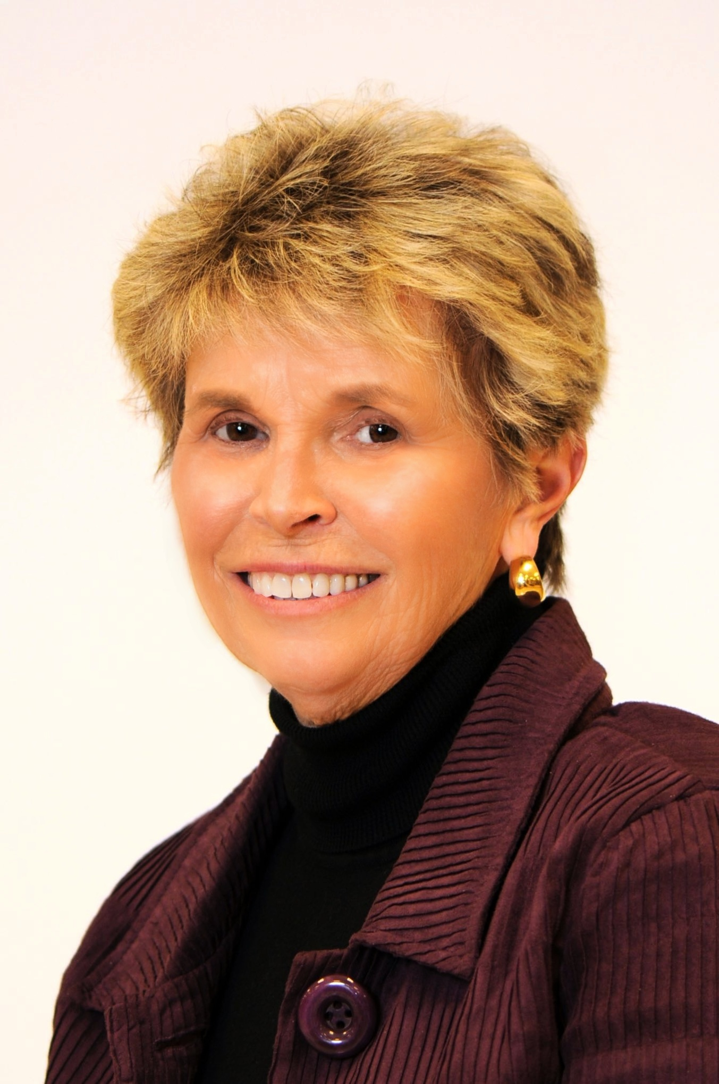

***Ed Snow*** – Has been a Job Club Volunteer since the Club Founding in 2009. He is a retired Army Officer, Production Plant and Manufacturing Executive who ***reviews resumes, mentors and coaches job seekers***. Ed facilitates the Club meetings the first week of each month and ***assists in mentoring those in the Job Search Essentials special interest group.***

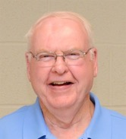

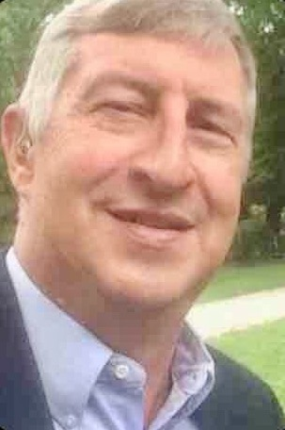

***Gary Bond*** – Volunteers as a co-lead of the ExperiencePlus special interest group. Fellow job seeker in the systems engineering field.

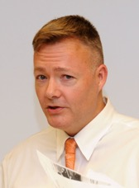

***Doug Brazier*** – Is Calhoun Community Colleges’ Outreach Coordinator and volunteers as a Club Meeting Facilitator the second week of each month. Doug was a job seeker and knows the hardships of looking for a position for a long period. He ***stresses the importance of Networking to all Job Seekers*** since that is the way he, and many of the people he helps, find their jobs.

***Vic Cordier*** – is a retired Army Reserve Officer and a counselor at the Decatur Alabama Career Center, located at 1819 Bassett Avenue, SE. Vic’s focus is on finding jobs for veterans in the Decatur Metro Area.

***Deione Crutcher –*** Works at Alabama Huntsville Career Center and is a Club Presenter and Community Liaison working with Club members to find employment.

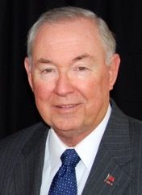

***Dud Fagan*** – Is a retired Army Officer; retired Raytheon Program and ***Hiring Manager***; and a retired CEO of a group of manufacturing and engineering companies in England. He volunteers as a Club Presenter; Fill-In Meeting Facilitator; ***Resume Reviewer; Coach & Mentor for Job Seekers***; and manages the Club’s web site. Dud is a ***co-lead for the Job Club’s Job Search Essentials*** special interest group that meets at 2 PM after each Club meeting.

<https://www.linkedin.com/in/dudley-fagan-a5a39978/>

***Dave Fledderman*** – Is a retired US Government Employee on Redstone Arsenal, and is our long-time volunteer ***Google Group Manager*** for the Job Club.

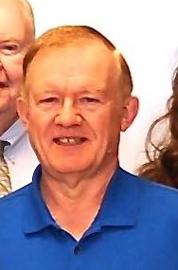



***Fred Folks*** – Is a job seeker in the Aviation sector. He volunteers at the Club to ***set up the venue and refreshments and assists in welcoming new Club members***. Fred also assists with our technology issues for audio visual systems.



***George Giller*** – Is a job seeker in Mechanical & Systems Engineering, Design Engineering, or Technical Management. George volunteers at the ***Club as our technology expert***. He is also responsible for clean-up of the venue and requests that we use only one trash can and one recycle container at each meeting.

***Danny Garcia*** - Is the St John’s Church Parish Ministries Outreach Coordinator and assists the Club in administration and conduct of the meetings in the Church facilities. Danny, and the rest of the Church Office Staff, ***provide numerous services*** to the Club and ***newcomers wishing to join*** the Club by ***answering questions*** and ***offering our Resume Book*** to those ***Company HR personnel*** coming to the Church ***looking for qualified candidates***.

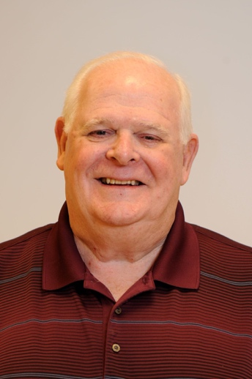

***Fran Henry*** – Is a ***retired Human Resource professional*** with many years’ experience locally with manufacturing companies such as SCI. He volunteers at the Job Club to ***review resumes and coach job seekers***. Fran is a co-lead of the ***ExperiencePlus Group.***

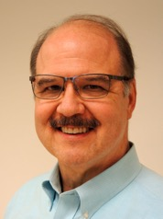

***John Haley*** – Volunteers at the Job Club as ***a presenter and Community Liaison offering great leads on job opportunities***



***Herb Hayes*** – Is retired Army, a retired Federal Worker on Redstone Arsenal, a former business owner and adjunct professor. Herb volunteers as a ***presenter, reviews resumes, coaches job seekers, and assist anyone seeking Federal Employment***. Herb has extensive experience advising in financial planning.

***Carla Holder*** – is a job seeker in the Financial Field. She volunteers at the Job Club as our ***Librarian, maintaining a library of extensive books on job searching***, and is a good contact for the ***local financial and Quality networking organizations***. Carla is also the ***Leader of the ExperiencePlus Group***.

<https://www.linkedin.com/in/carla-holder-284110/>

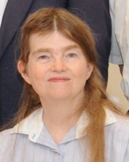

***Melinda Inglis –*** is a Career Coach and Career Advisor and works for a local Credit Union. She has assisted with regional workforce efforts and stays appraised of workforce shifts.  Melinda has been a Job Club guest facilitator, assisted in procuring community and business speakers, and ***is willing to assist members with revising their resumes, providing job search tips, and helping individuals plan for a new career field.***



***Katharina Loudin*** – Works at the local Hogan Family YMCA and volunteers in our Club as the ***Meeting Speaker Coordinator***. If you have a subject or speaker you think would benefit the Club – please contact Katharina and tell her. She will contact the speaker or find a speaker to present that subject.

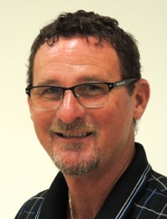

***Mike Marty*** – Is an experienced ***Human Resource professional*** who volunteers at the Job Club to make presentations, ***review resumes, and is an excellent coach for job seekers in their interviewing skills.***

***Sam Scruggs –*** Is a Club Volunteer and works at the North Alabama Center for Educational Excellence (NACEE). He is a Retired Army Officer, Educator, & Business Owner. Sam can **provide job seekers (especially Veterans) job leads, and directions to community resources; he also helps to obtain and provide educational opportunities and funding resources for middle school, high school, and college students, and adults.**

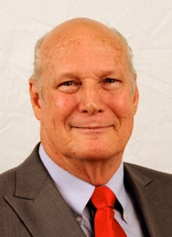

***Sidney Stevens*** – Is a job seeker in the ***Program Management*** field and has a PMP certification. He volunteers at the Job Club as a presenter and is a ***manager of the Job Club’s Resume Book***. ***Talk with Sidney to place your resume into the Job Club Resume Book which is kept in the Church Office during the week and has many HR professionals come review the book to source job candidates. We have had some job seekers get interviews this way.***